**4th Lab –** **Traffic Light Control Using AT89C51 Microcontroller**

**Implementation:**

**Keil:**

Open Keil µVision → Go to Project → New µVision Project → Set a project name and save it → In the Select Device for Target window, search and select AT89C51 → Click OK → When prompted, click No → In Project window, right-click Source Group 1 under Target 1 → Select Add New Item to Group 'Source Group 1' → Create and save a new C file → Write the code below and save:

**Source Code:**

#include <reg51.h>

sbit red = P2 ^ 0;

sbit yellow = P2 ^ 1;

sbit green = P2 ^ 2;

void Delay(int time)

{

    int i, j;

    for (i = 0; i < time; i++)

    {

        for (j = 0; j < 1000; j++)

        {}

    }

}

void main()

{

    yellow = 0;

    red = 0;

    green = 0;

    while (1)

    {

        red = 1;

        Delay(200);

        red = 0;

        yellow = 1;

        Delay(200);

        yellow = 0;

        green = 1;

        Delay(200);

        green = 0;

        yellow = 1;

        Delay(200);

        yellow = 0;

    }

}

→ Right-click Source Group 1 → Add Existing Files to Group → Select the saved .c file → Click Add and Close → Right-click Target 1 → Options for Target → Go to Output tab → Check "Create Hex File" → Go to Target tab → Set Xtal (MHz) to 11.0592 → Click OK → Press F7 to build the project → If there are no errors or warnings, your code is okay.

**Proteus:**

Open Proteus → Click New Project → Set project name → Keep clicking Next until Finish → Click Finish → From the left sidebar, select Component Mode → Click P → Search and add AT89C51 → Add LED ×8 → From the sidebar, select Terminals Mode → Add Ground

**Component Placement:**

Place U1 (first AT89C51) on the workspace → Place Traffic Lights at the Side

**Wiring:**

Connect U1 P2.0–P2.2 (pins 21–23) to anode side of Red, Yellow and Green LEDs

**Programming:**

Double-click U1 → Set clock frequency = 11.0592MHz → Browse and select U1's HEX file → Click OK

**Simulation:**

Click the Play button → If Traffic Lights blink correctly, your setup is working → Save the project

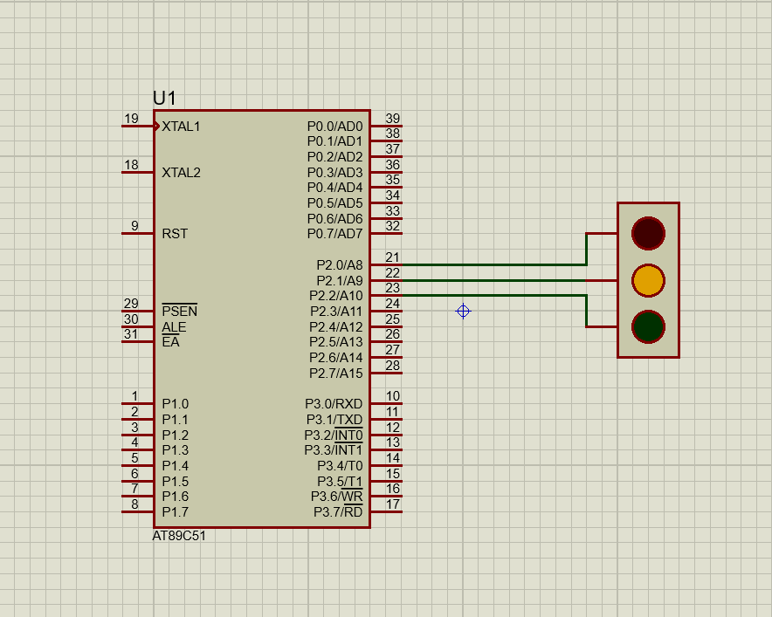**Diagram:**